Vehicle Parking App - V1
Project report for the MAD1



IITM Online BS Degree Program,
Indian Institute of Technology, Madras, Chennai
Tamil Nadu, India, 600036

Contents
1 Author 3
2 Description 3
3 Technologies used 3
4 Architecture and Features 4
5 Demo Video Link 4
6 GitHub Repo Link 4
7 DB Schema Design 5

- Author
Name: Joshna Prashant Dhanokar
Roll no: 21f2000753
Student Email: 21f2000753@ds.study.iitm.ac.in
As a senior software engineer, I specialize in full-stack development using Python and SQL. I am committed to advancing my skills and see the prestigious courses at IIT Madras as a pivotal opportunity to do so. Earning credentials from IIT Madras would enhance both my technical and academic profile. I’m confident this will enable me to innovate more effectively, tackle higher-level challenges, and unlock new opportunities for professional growth. I am fully prepared to embrace the rigorous learning process and apply the new insights directly to my work.

- Description
Vehicle Parking App – V1
A role-based application developed for managing 4-wheeler parking spaces efficiently. It supports two user roles: Admin, who oversees parking lots, spots, and monitors all parked vehicles, and User, who can book and release parking spots. The system ensures smooth parking operations through clear role separation and centralized control.

- Technologies Used
Backend | Python, Flask
Frontend | HTML, CSS, Bootstrap, JavaScript
Database | SQLite
Templating Engine | Jinja2

- Architecture and Features
The platform will have two roles Admin and Users
Key Features:

Admin (Superuser):
- Pre-configured login (no self-registration)
- Create, update, and delete parking lots
- Monitor real-time occupancy status across all lots
- View details of all registered users
- Access and manage all parking spot information

Users:
- Register and login with basic personal details
  - Browse and search parking lots by name, address, pincode, or price
  - Auto-assign available parking spots during booking
  - Release reserved spots with automated cost calculation
  - View current and past reservations
  - Download or print payment receipts for bookings
  - View active reservations in real time

- Demo Video Link

- GitHub Repo Link
https://github.com/21f2000753/vehicle_parking

- DB Schema Design

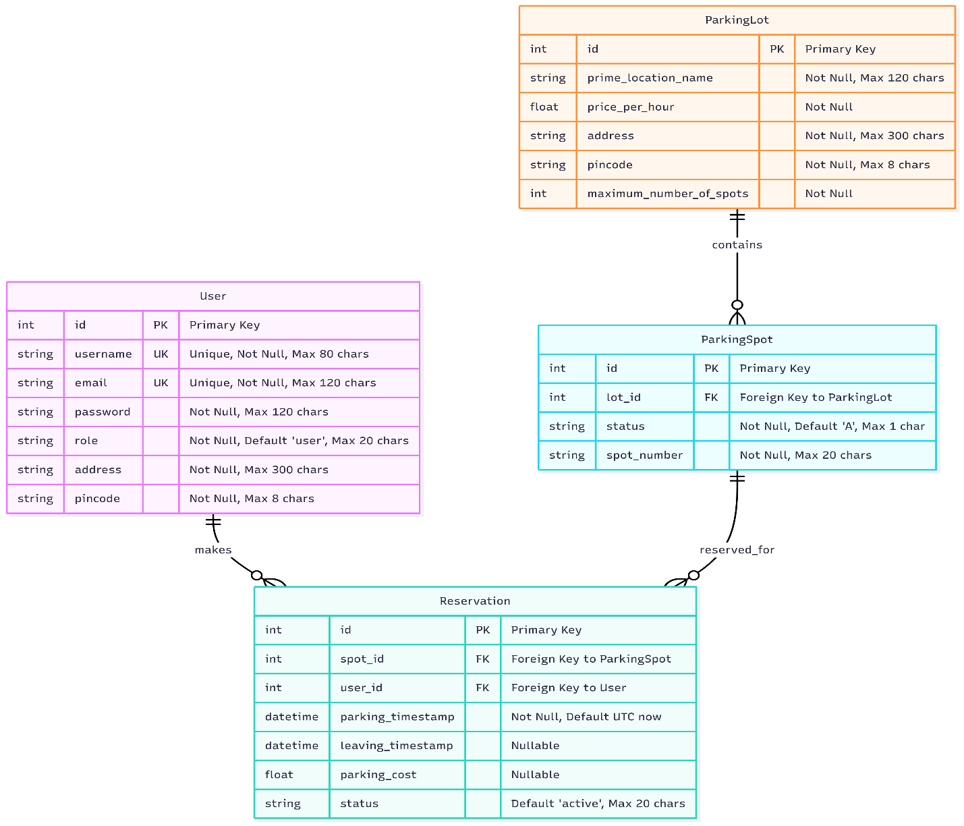

Entities and Relationships:
- User → Reservation (One-to-Many)
- ParkingLot → ParkingSpot (One-to-Many)
- ParkingSpot → Reservation (One-to-Many)

